项目建议书表格Project Proposal Form
（重点景观）
Project Title:
项目名称：
Project start and end date (2-3 years, not exceeding 3 years):
项目起止日期(2－3年，不超过3年) ： ____________________
Budget: 1. Requested from GEF SGP （local currency, not exceeding$50000）:
预算： 从GEF 小额赠款申请的经费（人民币，不超过等值5万美金）： ____________________
2. Contribution from others including from communities as follows（local currency）:
其他资金来源包括社区的捐赠（人民币）
Donor/local partner  出资方/当地合作伙伴 | In cash现金 | In kind非现金

3．Total project cost（local currency）: 项目总经费（人民币）: ____________________

GEF SGP Classification 项目类别
Thematic/Focal Area (Tick one)  主题/重点领域 （打勾） |  |  | Project Category (Tick one)  项目分类（打勾）
 | Conservation of Biodiversity（including snow leopard conservation project）  生物多样性保护  （包括雪豹保护特别项目） |  |  | Demonstration Project  示范项目
Capacity Development Project
能力发展项目
 | Climate change mitigation  减缓气候变化 |  |  | Building Partnership / leveraging other resources  建立伙伴关系/撬动其它资源
 | Climate change mitigation  减缓气候变化 |  |  | Networking or building alliance /Policy Dialogue  建立网络或联盟/政策对话
 | International waters  国际水域（红树林、珊瑚礁、海草床、滨海湿地的保护、防治陆源污染、可持续渔业） |  |  | Scaling up/ replication of SGP achieved results  升级/复制小额赠款项目取得的成果
 | Multi-focal*  多领域 |  |  | Innovation project integrating environmental protection, sustainable livelihood and community empowerment  环境保护、可持续生计和社区赋能相结合的创新型项目
* Proposal addresses more than one focal area项目建议书涉及一个以上的重点领域。

Priority landscapes project located （tick one）项目所处的重点景观 （打勾）
 | 滇西北三江并流地区高山峡谷景观 | 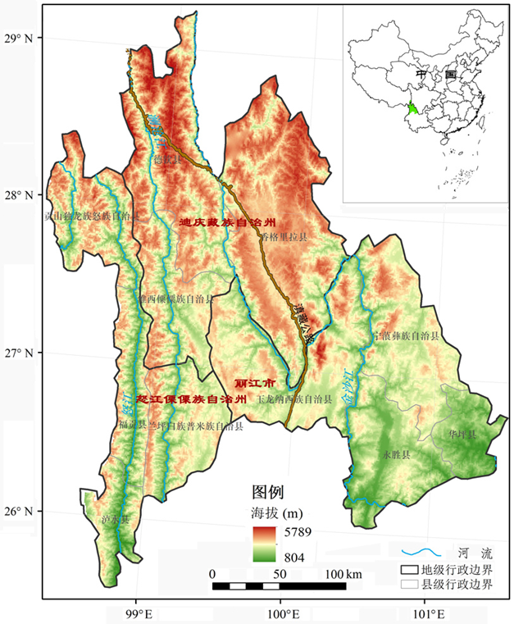  云南省的怒江傈僳族自治州、迪庆藏族自治州和丽江市的8个县66个乡  本次征集,该地区只支持减缓气候变化项目
 | 三江源高寒草地湿地景观  北部湾热带海岸带景观 | 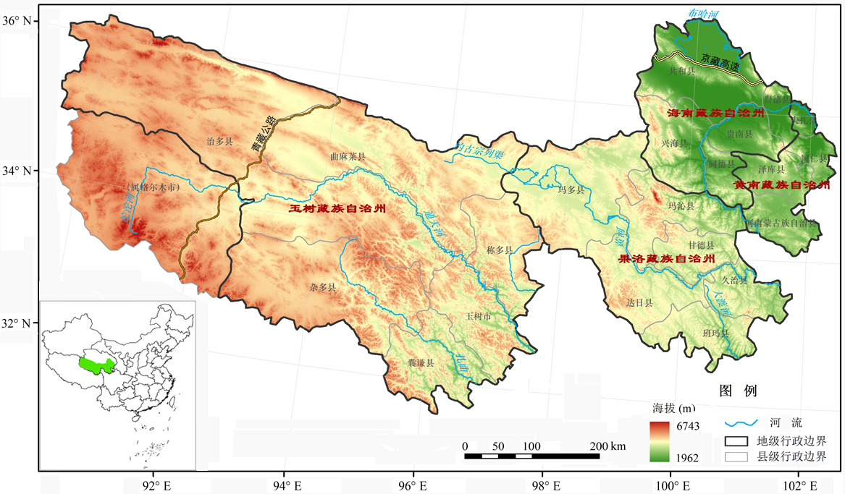  青海省玉树藏族自治州、果洛藏族自治州、海南藏族自治州和黄南藏族自治州的21个县160个乡镇及格尔木市的唐古拉山镇  本次征集该地区只支持减缓气候变化项目  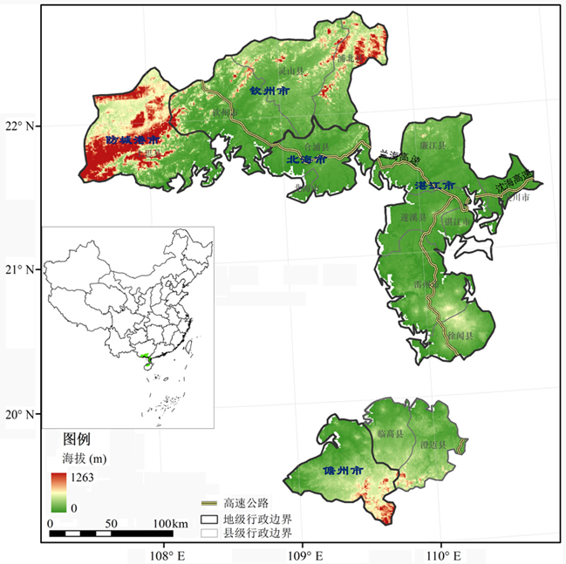
广西壮族自治区的北海市、钦州市、防城港市，广东省湛江市和海南省的儋州市等行政区，共9区8县4(县级)市，包括243乡镇。
海洋（海岸带）生物多样性保护和可持续利用及减缓气候变化两个领域的项目

About the Proponent:申请者简介
Name of Organization机构名称:
Organization Registration No. 机构统一社会信用代码:
Date of Founding成立日期:
Number of members 机构人数：全职人员______名，兼职人员______名。
Person in Charge负责人:
Bank information:银行信息：开户行____________ 银行开户许可证核准号__________ 帐号____________账户名称______________________
Coordinator 联系人:
Address地址:
Phone电话:
Fax:传真
E-Mail 电子信箱:
Organization Website机构网站:
References （two people from other organization who know your organization well）
推荐人 (来自其他机构、对你机构有充分了解的2位推荐人)
- Name姓名______ Title 职务______ organization 机构 ______ telephone 电话______ email 邮箱 ______
- Name姓名______ Title 职务______ organization 机构 ______ telephone 电话______ email 邮箱 ______

Brief history of organization（including Number of projects implemented）机构的简要历史（包括实施项目的数量）:

Relevant experience of organization机构在所申请项目领域的相关经验:

Project staff (please indicate names and roles in this project including project team members and financial staff)
项目成员（请说明参与本项目的人员姓名及在本项目中的职责包括项目组成员和财务人员）

1. Targeted Location and Population :(Briefly Describe location, coordinates (longitude and latitude) ,geographical details and living conditions of target population, with relevant maps attached)
目标位置和人口: （简要描述项目点的位置, 经纬度，地理信息和目标人群生活状况,请另加一页附上项目点在中国的位置地图。）

No. of households: ______ No. of population: ____________Ethnic/Religious representation____________
项目点有多少户： 项目点人数： 项目点民族或宗教组成：
Annual average income/person: __________________
项目点人均年收入：
No. of participating Male _________No. of participating Female ________No. of participating children _________
参与项目的男性人数: 参与项目的女性人数: 参与项目的儿童人数;
No. of participating households: __________
参加项目的家庭数量：

- Introduction: 背景介绍
- Baseline assessment of relevant environmental and socio-economic conditions (The baseline assessment is essential so that changes and impact brought about by the project intervention can be evaluated. It is also important to include an overview of other interventions in the area, both ongoing and planned, by local, national, and international organizations.)
相关环境和社会经济状况的基线信息 （基线信息的评估是必不可少的，目的是为了评估通过实施项目所带来的改变和影响。描 述当地，国家和国际组织在当地正在进行的项目或计划实施的项目的总体情况也很重要。）

- Main problems and needs主要问题和需求

- Rationale /Solutions基本原理/解决方案

- Anticipated results/outcomes 预期成果

- Project contribution to SGP targets for the 6th Operational Phase 项目对小额赠款计划第6执行阶段目标的贡献
Which GEF focal areas and SGP objectives does this project comply with? Please check one or more boxes as appropriate
这个项目符合GEF的哪个重点领域和SGP的哪个具体目标?请在方框内勾出一个或多个适合的选项。
3.1 Maintain globally significant biodiversity and the ecosystem goods and services that it provides to society
维持全球重要的生物多样性和生态系统提供的产品和服务
3.2 Support to transformational shifts towards a low-emission and resilient development path
支持低排放和有复原力发展道路的转型变化
3.3 Promotion of collective management of transboundary water systems and implementation of the full range of policy, legal, and institutional reforms and investments contributing to sustainable use and maintenance of ecosystem services。
促进跨界水系统的集体管理和政策、法律、制度变革以及投资的全面实施，贡献于维持生态系统服务和可持续利用。

4. Specific objectives in this project (You may consider: What does the project want to change? How will things be different after this project has ended? What will people do differently after participating in the project from what they do now?)
项目的特定目标 （你可以考虑：这个项目想改变什么？项目结束后会有什么不同？参与项目后人们会有什么跟现在不同的改变？）

1） _______________________________________________________________
2）______________________________________________________________
3）______________________________________________________________
When planning proposed activities, please consider time availability of target population and major stakeholders. Seasons and climatic conditions are also important factors. Some activities may readily be carried out using pre-existing community resources, without having to wait for cash transfer from GEF SGP.
在设计项目活动时，请考虑目标人群和利益相关方的时间有效性以及季节、气候条件等因素。一些活动利用社区已有的资源更易开展，不必等GEF SGP的汇款到达就可以进行。
Proposed activities to achieve the objectives  为达成目标而建议的活动 | Anticipated results  预期的成果 | Indicators  衡量指标（请参考附件5项目层面指标设定的指南）
Activity1.
项目活动
Activity 2.
项目活动
Activity 3.
项目活动
Activity 4.
项目活动
Activity 5.
项目活动
Activity 6. ……
项目活动 ……

5. Project Workplan and Monitoring Schedule项目工作计划及监督时间表
Project Number: |  | Project Name项目名称:
Name of Grant Recipient受款单位名称:
Brief Description of General Objective of Project:
简要描述项目的总体目标
GEF Focal Area (e.g. biodiversity, climate change etc.) :  GEF重点领域(如生物多样性、气候变化等) |  |  | GEF Operational Phase: OP6  GEF执行阶段：第6执行阶段 |  |  |  |  | Project Start and End Dates:  项目起止日期(请精确到日)
Brief Description of Specific Objective #1:
简要说明特定目标1
List the activities necessary to fulfill this objective. Indicate who is responsible for each activity and an indicator for each outcome.  列出实现上述目标的必要活动，每项活动的负责方及活动成果的指标 |  |  |  | Duration of Activity in Months (or Quarters)  活动开展的时间（按月或季度）
Activity活动 | Responsible Party  负责方 |  | Indicator指标 | 1 | 2 | 3 | 4 | 5 | 6 | 7 | 8 | 9 | 10 | 11 | 12
1.1
1.2
1.3
1.4
Brief Description of Specific Objective #2:
简要说明特定目标2
Activity | Responsible Party |  | Indicator | 1 | 2 | 3 | 4 | 5 | 6 | 7 | 8 | 9 | 10 | 11 | 12
2.1
2.2
2.3
2.4
Indicate persons responsible for monitoring and progress reports:  说明负责项目监督和进展报告的人 |  |  |  | Monitoring and evaluation / Reporting Frequency 监督/报告的频率
Monitoring and
Record-Keeping 监督和存档
Progress Reports进展报告
此表可以根据每个项目的具体情况进行修改。也可另加页以包含所有的项目目标及活动。此表的活动是上面第10页表中活动的细分，应与之保持一致。This form can be modified based on the specific circumstances of each project. Additional pages may added to include all the activities and objectives. The activities indicated in this table are subdivision of and should be in line with the ones in the above table on page 10.

6．Plan to improve the livelihood of the locals 提高当地人生计的计划

7．Plan to ensure community participation (describe how the relevant communities will be involved in: i)Project planning and design; ii) Project implementation and iii) Project monitoring and evaluation)
确保社区参与的计划（描述相关的社区是如何参与:①项目的规划和设计, ②项目的实施③项目的监督和评估）

8．Knowledge Management (describe how you plan to capture, share and disseminate the knowledge, lessons learned and good practices gained through the implementation of the project)
知识管理（描述如何计划获取，分享和传播通过项目实施所得到的知识，经验教训，最佳实践）

9．Participation of Women, youth and indigenous people （describe how the project takes into consideration the roles and needs of women, youth and indigenous people, and how this project will enhance their capacities and empower them to bring benefits to this project）
女性、青年、原住民的参与（描述项目如何考虑女性、青年、原住民的作用和需求，以及项目将如何提升他们的能力，能他们赋权，以给项目带来益处）

10. Major risk factors and approaches for solution/avoidance: 主要的风险因素及解决/避免的方法
Problems and issues are common in any project implementation. These risk factors should include both internal factors and external factors. Would there be any which are discernible to emerge during project duration? If so, please give a brief solution/prevention to minimize the risk.任何项目实施过程中通常都会存在困难和问题。这些风险因素包括内部因素和外部因素。在项目期间会出现任何可以识别的风险因素吗？如果有的话，请简要说明解决或避免风险的方法。
Risk factors/ problems 风险因素/问题 | Approaches for solution/prevention解决/避免的方法
1) ．  2) ．  3) ． | 1)  2)  3)

11. Sustainability of Project Results: 项目成果的可持续性
Please outline the steps to be taken before, during, and at project completion to ensure that once all the SGP funds have been disbursed, the project impact will continue for many years thereafter. Project applicants should plan ahead when all the funding is used up after 3 years or even 5 years and consider the factors that could contribute to the success and continued impact of their project, and address them accordingly.
请概述在项目实施前，实施中和项目结束后采取的各个步奏以确保小额赠款项目的资金支付完毕后，项目的影响还能持续很多年。项目申请者应该提前设想项目资金用完后3年甚至5年后的情况，考虑确保项目成功和维持项目影响的因素，并相应的加以说明。

12. Project Budget: 项目预算
Fill in the figures according to actual needs. If there is no expected expense in some categories, leave the columns blank. If there are other expenses beyond these categories, please adjust this table accordingly and specify.根据实际需要填写数据。如果某些类别没有预期的花费，请空着不填。如果有超出以下类别的花费，请调整表格并特别说明。
Category of Expense  预算类别 |  | Expected expenditure  预计支出 | Grant request from GEF-SGP  从小额赠款计划申请的资金 | Co-financing sources  配套资金来源
 |  | Expected expenditure  预计支出 | Grant request from GEF-SGP  从小额赠款计划申请的资金 | Community  社区 |  |  | Proponent  申请机构 |  |  | Government  政府部门 |  |  | Others  其他
 |  | Expected expenditure  预计支出 | Grant request from GEF-SGP  从小额赠款计划申请的资金 | Cash  现金 | In-kind  非现金 |  | Cash  现金 | In-kind  非现金 |  | Cash  现金 | In-kind  非现金 |  | Cash  现金 | In-kind  非现金
1、Budget for activities项目活动预算（≥ 90%）
Manpower/labor人工/劳力
Training/Seminar/ Workshops, etc.
培训/讨论会 /研讨会等
Contracts分包合同
Equipment/Furniture设备
Others  其他 | Travel/lodging/meal  交通食宿
Others  其他 | Outreach and knowledge management  宣传和知识管理
Miscellaneous杂费
Subtotal小计（1）
2、Admin budget行政管理预算（≤ 10%）
(Please specify)请具体说明
(Please specify)请具体说明
Subtotal小计（2）
Total（1）+（2）合计
Note: This table should be adjusted and expanded as needed. Please attach the detail of estimate in separate sheets. 注：此表可根据需要调整和扩充。请单独附上详细的财务表。
Projected expenditures under GEF fund per annum during project cycle项目周期内按年的GEF资金的预期支出
Expenditure Category 支出类别 |  | Year 1, [local currency]  第1年（人民币） | Year 2, [local currency]  第2年（人民币） | Year 3, [local currency]  第3年（人民币）（如有） | Total, [local currency]  合计  （人民币） |  | US$ (please leave for NC final calculation)  美元（请留空，由国家协调员最终计算） | % Total of GEF  占GEF总预算的％
Manpower/labor人工/劳力
Training/Seminar/ Workshops, etc.
培训/讨论会 /研讨会等
Contracts分包合同
Equipment/Furniture设备
Others  其他 | Travel/lodging/meal  交通食宿
Others  其他 | Outreach and knowledge management 宣传和知识管理
Miscellaneous 杂费
Administrative cost 行政管理开支
Total 合计

